
CORPORATE PROFILE · SAUDI ARABIA & GCC · 2026
STARTAXIS
Enterprise Intelligence 360
AI-Powered Management Intelligence, Automation & Agentic AI Platform

OUR PROMISE
See the whole business. Know what to do next.
StartAxis converts fragmented business information into trusted management intelligence, predictive insight and governed action - without forcing organisations to replace the systems they already use.

EXECUTIVE OVERVIEW

Practical AI for better business decisions and disciplined execution
StartAxis Consulting is a Riyadh-based business transformation and enterprise AI intelligence advisory founded to help organisations convert strategy, data and operational experience into measurable performance.
StartAxis Enterprise Intelligence 360 is an AI-powered management intelligence layer that works above existing ERP, CRM, finance, HR, operational systems, databases, spreadsheets and approved company knowledge. It provides one role-based view of performance, explains why results changed, forecasts what may happen next and helps management move from insight to accountable action.
IMPORTANT
Keep the systems that already run your business.
StartAxis can connect through agreed APIs, read-only databases, SQL or ETL feeds, and controlled Excel, CSV or Google Sheets exports. Clients retain control over access, hosting and data location.

What organisations gain
- One management view: Unified financial, commercial, operational, workforce, customer, project and risk intelligence.
- Faster decisions: Automated summaries, exceptions, root-cause explanations, forecasts and recommended actions.
- Better execution: Clear owners, deadlines, approvals, follow-ups, escalation and outcome tracking.
- More productive teams: Role-specific AI copilots, workflow automation and secure knowledge assistants.
- Measurable value: Revenue, margin, cash, cost, productivity, customer and governance improvements tracked against agreed KPIs.
THE PLATFORM

Eight connected AI capabilities. One performance mission.
The platform combines management experience, data integration, generative AI, predictive AI, automation and governed AI agents within a practical operating model.

One governed intelligence engine connecting every agreed business function.
- AI Executive Command Centre: A single leadership view of revenue, margin, cash, operations, people, customers, projects, risks and strategic priorities.
- AI Decision Intelligence: Exception detection, likely causes, trends, forecasts, scenarios and recommended management actions.
- Agentic AI & Action Management: AI-supported reporting, task routing, approvals, follow-up and escalation with human oversight.
- AI Forecasting & Scenario Planning: Demand, cash, inventory, capacity, churn, staffing and profitability simulations.
- AI Workflow Automation: Reduced manual reporting, data consolidation, reminders, approvals and repetitive administration.
- AI Knowledge & SOP Assistant: Secure, source-grounded guidance from approved policies, procedures, checklists and knowledge.
- Data & KPI Integration: One governed KPI layer across systems, companies, branches and departments.
- AI Governance, Training & Adoption: Responsible-use rules, access control, auditability, human approval, adoption KPIs and capability building.
HOW IT WORKS

From existing business data to governed management action
We begin with one valuable management problem, establish trusted definitions and build an AI operating rhythm that leadership and teams can use every day.

Existing systems feed a secure intelligence layer; approved insight flows into decisions and accountable action.
- Connect. Securely connect agreed ERP, CRM, finance, HR, operational, database, spreadsheet, document and knowledge sources.
- Unify. Create common KPI definitions, data quality rules and one governed business context across functions, branches and companies.
- Understand. AI monitors signals, detects deviations, explains likely causes, identifies patterns and forecasts outcomes.
- Act. Leaders approve recommendations while AI agents support assignments, workflows, reminders, follow-up and escalation.
- Improve. Track outcomes, learn from decisions, refine management routines and expand into the next value area.
DEPLOYMENT CHOICE
Cloud, private cloud or on-premises - based on client requirements.
The implementation design is agreed with the client's management and IT teams. Data ownership, access rights, security, integrations and approval limits remain clearly defined.

AI-ENABLED WORKFORCE

The right intelligence for every role, at the right moment
StartAxis creates role-based AI experiences. Every user sees only the data, recommendations, tools and actions relevant to their responsibilities and approved access.

- Board, owners and CEO: AI briefings, strategic signals, scenario comparisons, investment risk and enterprise-wide action visibility.
- CFO and finance: Management reporting, cash forecasting, collections, variance analysis, cost control, working capital and profitability.
- COO and operations: Bottlenecks, SLA failures, downtime, capacity, productivity gaps and corrective-action management.
- Sales and marketing: Lead prioritisation, forecasts, churn signals, conversion, customer follow-up and market patterns.
- HR and people leaders: Workforce planning, attendance, capability mapping, onboarding, policy support and employee services.
- IT, data and compliance: Controlled access, traceable sources, security rules, human approvals, adoption monitoring and audit trails.
- Managers and frontline teams: Daily summaries, SOP guidance, task prioritisation, customer responses, reporting and faster problem-solving.
INDUSTRY INTELLIGENCE EDITIONS

Built around how each sector actually operates
Every edition is configured around the client's terminology, decisions, KPIs, workflows, controls and value drivers.


Automotive & Aftersales AI 360
Vehicle sales, lead funnel, workshop productivity, labour, parts, warranty, customer retention, branch contribution and demand signals.

Fleet, Leasing & Mobility AI 360
Utilisation, contracts, renewals, maintenance, downtime, collections, residual value, driver risk and asset profitability.

Logistics & Distribution AI 360
Orders, routes, warehouse flow, on-time delivery, fleet cost, customer SLA, inventory and disruption alerts.

Manufacturing & Industrial AI 360
Output, quality, downtime, maintenance, yield, cost, safety, capacity and AI-assisted production planning.

Construction & Contracting AI 360
Project margin, progress, labour, procurement, variation orders, cash flow, risk and delay prediction.

Retail, Wholesale & E-commerce AI 360
Sales, category margin, stock, pricing, promotions, customer behaviour, demand and channel performance.
INDUSTRY INTELLIGENCE EDITIONS

From service organisations to multi-business groups
StartAxis can begin with one branch or function and scale progressively across the organisation.

Healthcare & Clinics AI 360
Appointments, utilisation, patient flow, revenue, claims, service quality, staffing and operational alerts.

Hospitality & Restaurants AI 360
Occupancy or covers, revenue, food cost, labour, guest experience, wastage, forecasts and location performance.

Facilities & Property Management AI 360
Assets, work orders, SLA, tenants, vendors, energy, preventive maintenance, cost and compliance.

School & Education AI 360
Admissions, attendance, fees, academics, teachers, parents, transport, facilities, student risk and campus performance.

Gym & Wellness AI 360
Memberships, renewals, churn risk, trainer utilisation, engagement, equipment, collections and branch EBITDA.

SMEs, Family Groups & Multi-Business Intelligence 360
Group-wide companies, branches, cash, profit, growth, risks, shared services and owner priorities.

Additional configurable sectors
- Service businesses: Pest control, field services, maintenance, professional services and customer-support operations.
- Heavy equipment and industrial services: Pipeline, equipment sales, rental, parts, service, utilisation, maintenance and working capital.
- Trading and distribution networks: Product, supplier, inventory, channel, customer, receivables, margin and territory intelligence.
CONFIGURABLE BY DESIGN
Not a one-size-fits-all dashboard.
Each solution is designed around the management questions the client needs answered, the decisions users must make and the controls required to act safely.

MANAGEMENT INTELLIGENCE

What leaders can see, understand and improve
The command centre creates one version of the truth while department-level views translate enterprise priorities into role-specific execution.
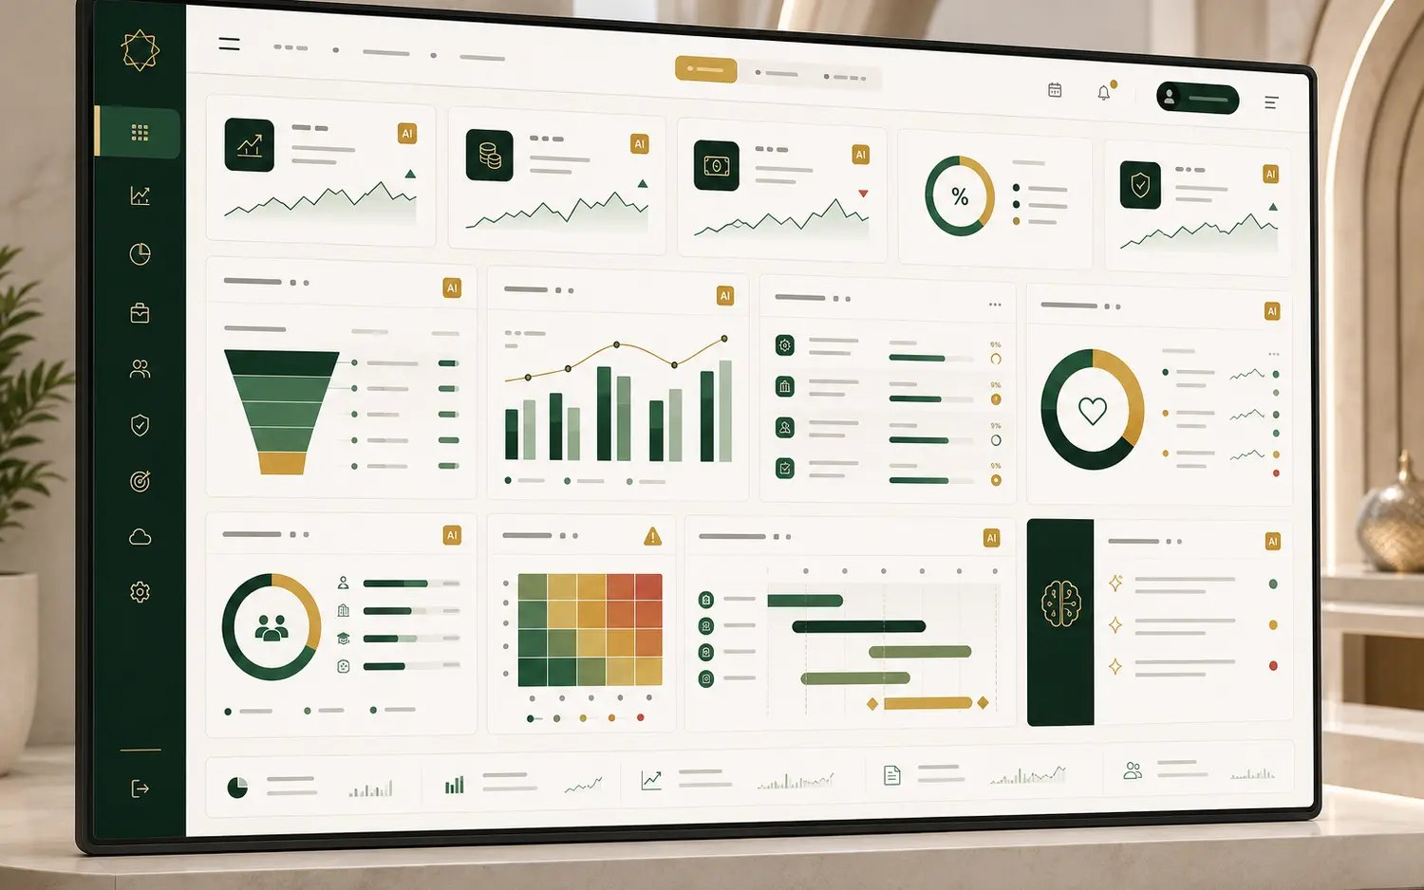
Illustrative dashboard using clearly identified sample data; final KPIs are agreed with each client.
- Financial intelligence: P&L, revenue, gross profit, EBITDA, cash, collections, receivables, expenses and working capital.
- Commercial intelligence: Pipeline, conversion, pricing, mix, customer acquisition, retention, churn and market performance.
- Operational intelligence: Capacity, productivity, SLA, quality, turnaround time, utilisation, downtime and process compliance.
- Inventory and asset intelligence: Stock age, slow-moving items, availability, carrying cost, asset yield, maintenance and residual value.
- People intelligence: Workforce, attendance, productivity, capability, compliance, Saudisation indicators and leadership actions.

Measurable business outcomes
- Growth: Higher revenue, better conversion, improved retention and stronger market execution.
- Profitability: Lower leakage and cost, improved margin, productivity and return on working capital.
- Control: Faster detection, stronger governance, clear accountability and disciplined corrective action.
GOVERNED AGENTIC AI

AI that does more than answer questions - while people remain accountable
Agentic AI can monitor agreed signals, prepare analysis and support execution within defined access, approval and audit boundaries.
- Observe. Monitor trusted KPIs, business events, documents, workflow status and authorised data sources.
- Reason. Explain what changed, identify likely causes, assess risk, compare options and estimate impact.
- Recommend. Prepare decisions, responses, action plans, reports, tasks or next-best actions for review.
- Act with approval. Route work, notify owners, follow up and escalate within controlled permissions and audit trails.
HUMAN-LED BY DESIGN
The client defines what AI may access, recommend, prepare or execute.
Sensitive actions remain subject to human approval. StartAxis supports role-based access, source traceability, approval limits, auditability, responsible-use policies and adoption monitoring.

Governance and technology principles
- Client-controlled data: The client retains ownership of data and determines hosting, access, retention and integration arrangements.
- Least-privilege access: Users and AI functions receive only the permissions required for approved responsibilities.
- Traceable intelligence: Important insights should reference approved sources and preserve reviewable logic or evidence.
- Human approval: Critical decisions and actions remain subject to defined management authority.
- Responsible adoption: Training, policies, change management and value tracking are built into implementation.
- Progressive scaling: Begin with a controlled use case, prove value, strengthen governance and expand responsibly.
BUSINESS TRANSFORMATION SERVICES

AI-enabled execution backed by 35+ years of operating leadership
Technology alone does not transform a business. StartAxis combines the platform with senior-led diagnostics, implementation, management routines, capability building and measurable performance improvement.

- Business diagnostics and transformation: Performance assessment, strategic priorities, transformation roadmap, governance and implementation.
- Sales and market growth: Pipeline, productivity, conversion, pricing, customer acquisition, channels and market expansion.
- Operational excellence: Process improvement, SOPs, productivity, quality, controls, service performance and continuous improvement.
- Profitability and cost optimisation: Margin leakage, contribution, cost structure, productivity, budgeting and sustainable savings.
- Working capital, inventory and collections: Cash visibility, receivables, stock age, dead inventory, turns, credit control and collection discipline.
- Leadership, governance and capability: Accountability, review rhythms, coaching, AI training, adoption and execution discipline.
- Customer experience: Journey, standards, complaint management, retention, loyalty, service recovery and performance KPIs.
- Implementation support: Founder-led engagement alongside client teams until new operating practices are embedded.
START SMALL. PROVE VALUE. SCALE WITH CONFIDENCE.

The 7-Day Management Intelligence Sprint
A fast, low-risk starting point for one branch, department or priority management problem using an agreed data export from the client's current system.
FOUNDER-LED ENTRY OFFER
SAR 10,000 total investment
SAR 5,000 on confirmation and SAR 5,000 on prototype presentation. The fee is credited toward implementation when an agreed next-stage project begins within 30 days. Scope and commercial terms are confirmed in writing before work starts.

Sprint deliverables
- Leadership discovery. A focused 90-minute owner or leadership discussion to define the priority problem and decisions required.
- KPI and data-source map. A practical map of measures, definitions, users and available data for one agreed business area.
- Interactive dashboard prototype. A management-ready prototype built from an agreed export or clearly identified sample data.
- AI management intelligence. Top alerts, likely causes, forecasts and recommended actions relevant to the selected problem.
- Executive presentation and roadmap. A leadership review of value, gaps, integration options, governance needs and implementation phases.

Engagement options after the sprint
- Intelligence layer implementation: Connect agreed live feeds and deploy role-based dashboards, alerts and workflows above existing systems.
- Department or industry edition: Deploy a focused solution for finance, sales, operations, HR or a selected business segment.
- Enterprise or group rollout: Scale progressively across departments, branches, legal entities or countries.
- Advisory and transformation programme: Combine the platform with senior-led diagnostics, implementation and capability building.
FOUNDER-LED DELIVERY

Suresh Bhargav - Founder & Principal Consultant
35+ years of executive leadership across Saudi Arabia, the GCC and India, combining board-level perspective with hands-on implementation.

Suresh Bhargav has led multi-million-riyal businesses, managed teams of more than 400 employees and held senior roles across automotive, fleet, mobility, distribution, aftersales, heavy equipment, operational excellence, business transformation and performance management.
His work now combines this operating experience with enterprise AI intelligence, management dashboards, governed Agentic AI, workflow automation and role-based adoption - helping organisations transform AI from a technology trend into practical workplace performance.

Why StartAxis
- Senior-led: Every engagement is personally led by the founder, not handed over to a junior consulting team.
- Business-first AI: Use cases begin with management decisions, operating realities and measurable value - not technology for its own sake.
- Implementation-focused: StartAxis works alongside client teams from diagnosis and design through adoption and performance review.
- Locally relevant: Saudi and GCC operating context combined with cross-functional and multi-industry leadership experience.
BOOK A FOUNDER-LED LIVE DEMONSTRATION
Bring one management problem. See what StartAxis can reveal.
Suresh Bhargav | Riyadh, Saudi Arabia
+966 50 023 9337 | suresh@startaxis.net | www.startaxis.net

Visit StartAxis.net | Email Suresh | WhatsApp

